**MS Teams Info**

**MS Teams Link:**

<https://teams.microsoft.com/l/channel/19%3a4f48e1d86a5d4ff2a25d15b13d4d6f22%40thread.tacv2/A3%2520-%2520Written%2520Information?groupId=3171db72-dd19-4b67-bd03-2a23f03779e1&tenantId=d1323671-cdbe-4417-b4d4-bdb24b51316b>

**Meetings:**

25/01/22 | Agenda | Recording | Minutes

28/01/22 | Agenda | Recording | Minutes

01/02/22 | Agenda | Recording | Minutes

04/02/22 | Agenda | Recording | Minutes

07/02/22 | Agenda | Recording | Minutes

11/02/22 | Agenda | Recording | Minutes

14/02/22 | Agenda | Recording | Minutes

**25 January 2022**

**6:00PM**

**Video Recording Link:**

<https://rmiteduau-my.sharepoint.com/:v:/g/personal/s3932976_student_rmit_edu_au/EWjErlZnJtJJi52hJbL5cSQB0InDKbPsmNPO_KQhwDKeeQ>

**Meeting Agenda:**

Title of meeting: First meeting, assigning sections for Assignment 3 and discuss A5 draft

Date and time of meeting: 25/01/2022

Chaired by:

Attendees: Daniel C, Bryce M, Hanna S, Rhiannon L, Noah E

**Meeting goal:  Assign all sections for A3 and establish some deadlines, including A5 draft.**

**Agenda Item 1:** assign sections for A3

Time: 15

Purpose: set some deadlines, assign work segments

Leader:TBA

a. Discuss and go through criteria breakdown for A3

b. Everyone to choose or be assigned sections

**Agenda Item 1:** A5 draft discussion

Time: rest of meeting

Purpose: set some deadlines, assign work segments

Leader:TBA

a. Discuss and go through A5 draft script and storyboard

b. Set deadlines for draft script

**Meeting Minutes:**

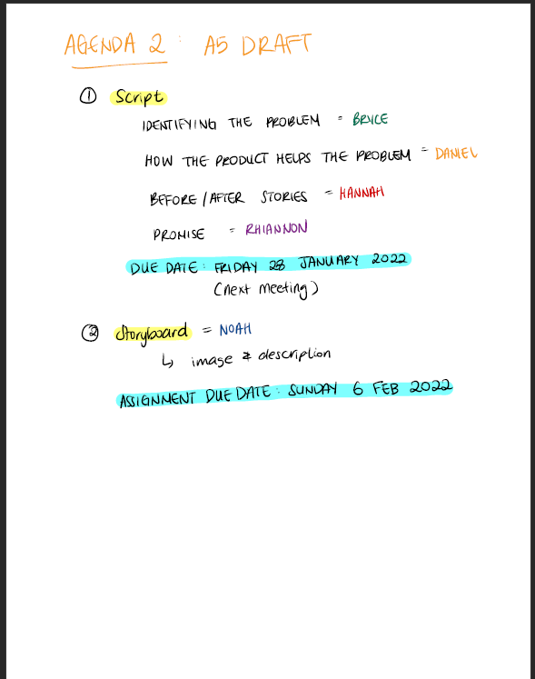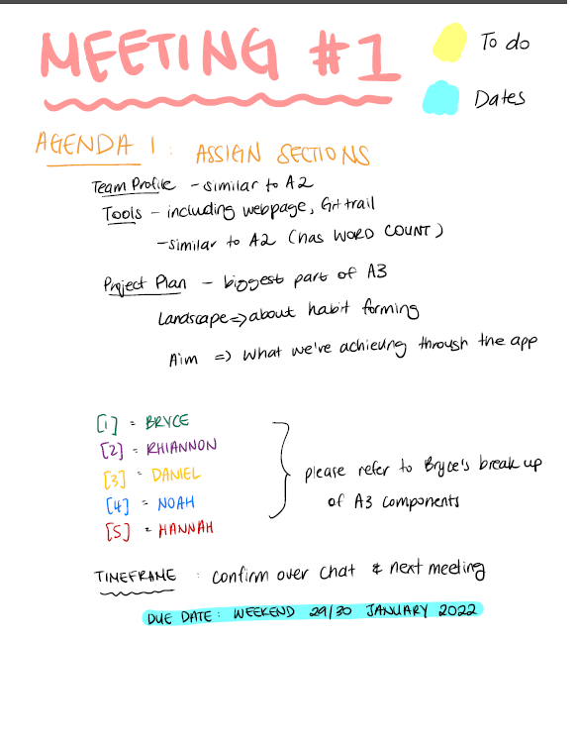

**28 January 2022**

**6:00 PM**

**Video Recording Link:**

<https://rmiteduau-my.sharepoint.com/:v:/g/personal/s3932976_student_rmit_edu_au/ET0PamO7Nv9Js-xFf9GGIPsBydZyPTbYvdE2Voe-n6v43w?e=OK2Qth&isSPOFile=1>

**Meeting Agenda:**

Title of meeting: Script draft discussion, A3 sections discussion

Date and time of meeting: 28/01/2022

Chaired by:

Attendees: Daniel C, Bryce M, Hanna S, Rhiannon L, Noah E

**Meeting goal:** Finalise the script draft, prepare for storyboarding. Set A3 deadlines

**Agenda Item 1:** Script discussion

Time: 15

Purpose: make sure its cohesive and ready for storyboarding

Leader:TBA

a. check completed parts

b. suggest changes

c. hand over for storyboarding

**Agenda Item 1:** A3 discsussion

Time: rest of meeting

Purpose: set some deadlines

Leader:TBA

a. assign priorities to sections

b. set deadlines

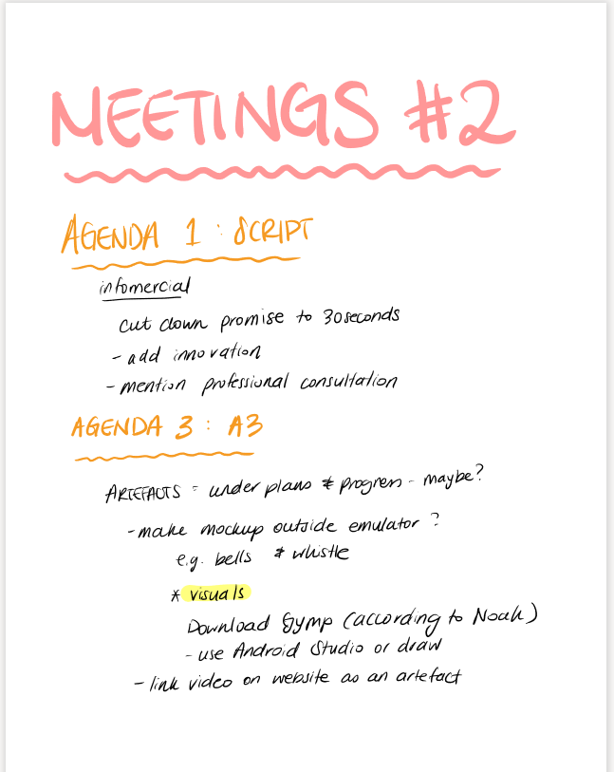**Meeting Minutes:**

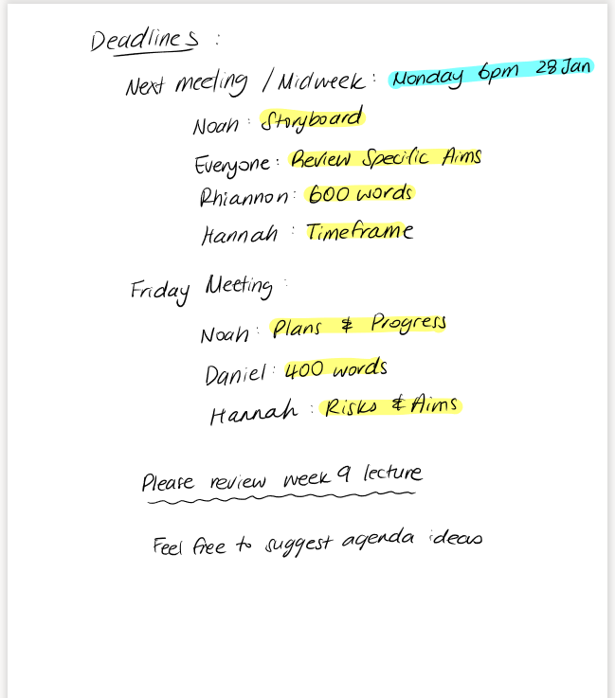

**01 February 2022**

**6:00 PM**

**Video Recording Link:**

<https://rmiteduau-my.sharepoint.com/:v:/g/personal/s3932976_student_rmit_edu_au/EVZ0CK_gra5Nmpa1sMVO2jcB9tCkQbT_GDriux99_RKWFQ>

**Meeting Agenda:**

Title of meeting: Aims brainstorm and general chat

Date and time of meeting: 01/02/2022

Chaired by:

Attendees: Daniel C, Bryce M, Hanna S, Rhiannon L, Noah E

**Meeting goal:**

**Agenda Item 1:** See where we are at with deadline progress

Time: 15

Purpose: check progress

Leader:

a. Script changes (Dan)

b. Review specific aims(all)

c. Storyboard(Noah)

d. words(Rhiannon)

e.Timeframe(Hannah)

**Agenda Item 2:** Specific aim section of assignment

Time: 15

Purpose: brainstorm a specific aim and goals

Leader:

a. specific aim

b. goals

c. goals

**Agenda Item 3:** General chat, any issues

Time:

Purpose: see how everyone is feeling

Leader:

1. Check how everyone is coping

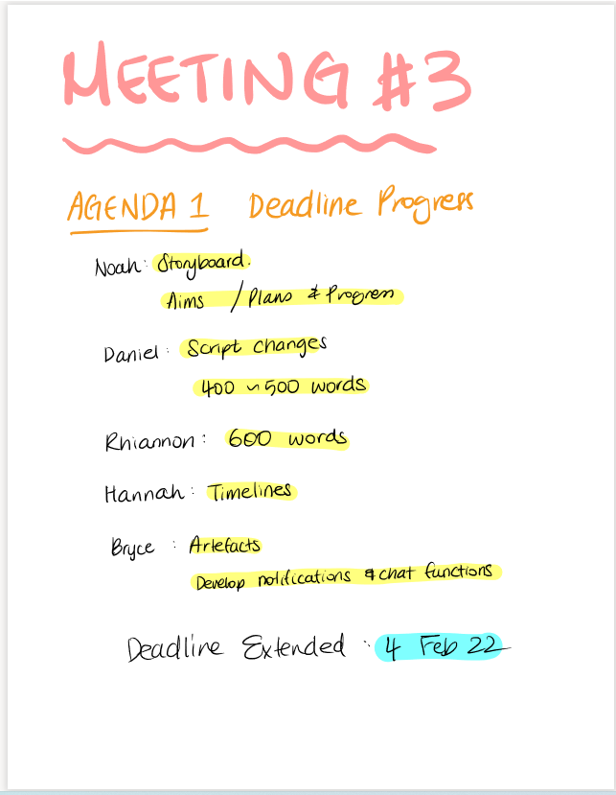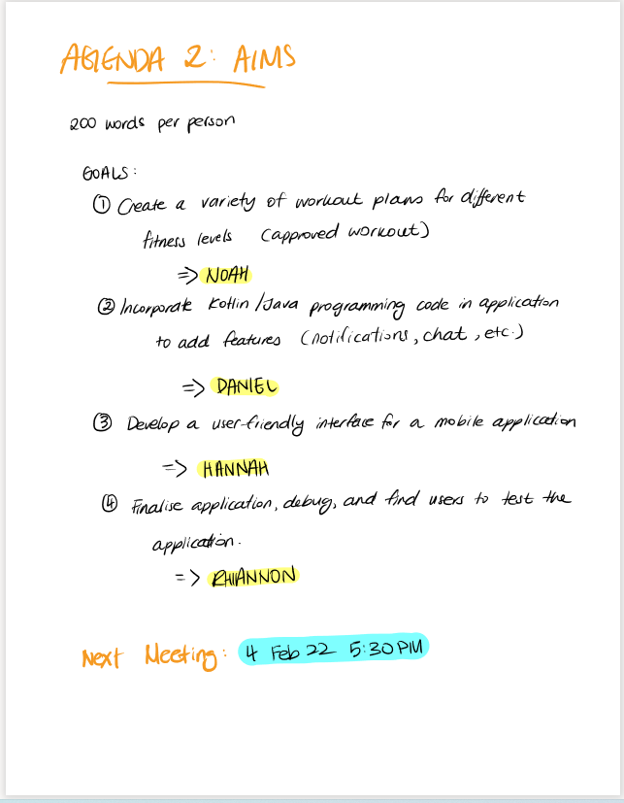**Meeting Minutes:**

**04 February 2022**

**5:30 PM**

**Video Recording Link:**

<https://rmiteduau-my.sharepoint.com/:v:/g/personal/s3923902_student_rmit_edu_au/EdRJ4Ve70D9NmpQgN0_DHW4BY5ngx-go1ivLVps3_hOK3w>

**Meeting Agenda:**

Title of meeting: Crunch time

Date and time of meeting: 04/02/2022 – 5:30PM

Chaired by: Daniel & Bryce

Attendees: Daniel C, Bryce M, Hanna S, Rhiannon L, Noah E

**Meeting goal:** Make sure everyone is on track, understands what needs doing, and deadlines are assigned!

**Agenda Item 1**: A3 written component finalisation

Time: 15

Purpose: To set final deadlines for all written content for A3

Leader: Daniel & Bryce

1. **Discuss what currently needs doing:**
   1. **EVERYONE** – AIMS section needs doing before next meeting
   2. **Noah** – Plans & Progress **(800w),** Testing **(300w)**
   3. **Hannah** – Plans & Progress **(800w),** Timeframe **(table),** Risks **(300w)**
   4. **Rhiannon** – Topic **(600w),** Scope & Limits **(300w + table),** Skills & Jobs **(700w)**
   5. **Daniel** – Motivation **(700w),** Landscape **(300w),** Tools & Tech **(400w)**
   6. **Bryce** – help anyone in need of assistance
2. Set final deadlines for individual sections of A3 for next Friday **(preferably all sections but at least ¾)**

**Agenda Item 2**: A3 completed sections

Time: 3-5

Purpose: Find out which sections are completed and discuss what to do once they are finalised

Leader: Bryce & Daniel

1. Find out which sections everyone has completed or started so far
2. Make sure everyone is aware to submit on MS Teams for review by others
3. After being reviewed make sure everyone is aware to upload to Git repo for incorporation into main documents and webpage

**Agenda Item 3**: A5 planning

Time: rest of meeting

Purpose: Draft is now complete so need to decide who will film which sections and what roles everyone will have

Leader: Combined

1. Make sure everyone reads over the script before next meeting
2. Find out who is comfortable appearing in the video
3. Decide roles for people who don’t want to appear in video
4. Ask for everyone’s preferences on sections **(maybe the sections they wrote except for Daniel, as this section will need to be shared)**
5. Discuss filming schedule to ensure everyone will have enough time **(for final week of assessment)**
6. Everyone to think about their preferred sections as roles will be assigned at next meeting

**Meeting Minutes:**

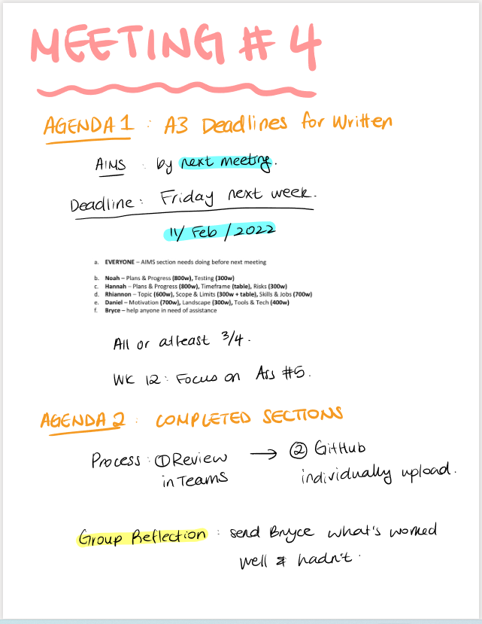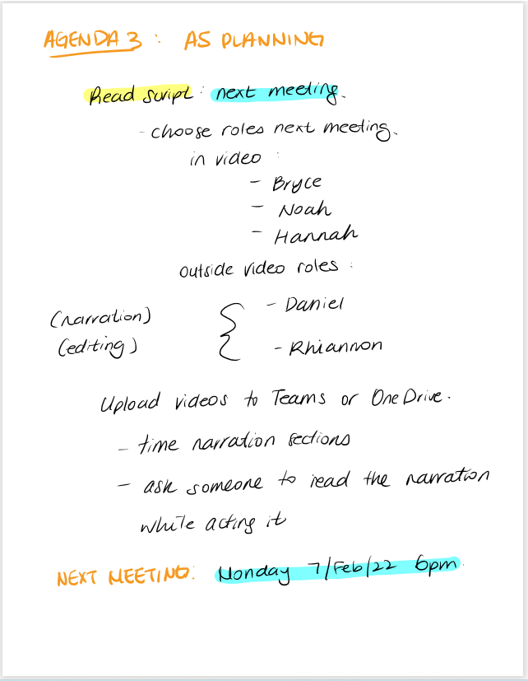

**07 February 2022**

**6:00 PM**

**Video Recording Link:**

<https://rmiteduau-my.sharepoint.com/:v:/g/personal/s3932976_student_rmit_edu_au/EYvMAJVkXk5GrAaERRQefmIBU3dVX_4F1KTjgBxfuEN0IQ>

**Meeting Agenda:**

Title of meeting: Video, Aims, A3

Date and time of meeting: 07/02/2022

Chaired by:

Attendees: Daniel C, Bryce M, Hanna S, Rhiannon L, Noah E

**Meeting goal**: Ensure all aims are uploaded, track A3 progress, discuss video further (assign roles)

**Agenda Item 1**: Get all Aims (and timeline) uploaded to Git

Time: 10

Purpose: ensure all our finished content in the Aims section and the timeline section are uploaded to git by the person who completed the content

Leader: Bryce

1. Aims uploaded
2. Timeline uploaded

**Agenda Item 2**: Check progress of A3 written content

Time: 5

Purpose: Quick discussion on A3 written sections, any problems, questions etc

Leader: Dan

1. If no issues or questions move on

**Agenda Item 3**: A5 video discussion

Time: rest of meeting

Purpose: Mae progress on A5

Leader: TBA

1. Review content, script, storyboard etc
2. Discuss roles
3. Assign roles
4. Discuss recording techniques and tips etc.

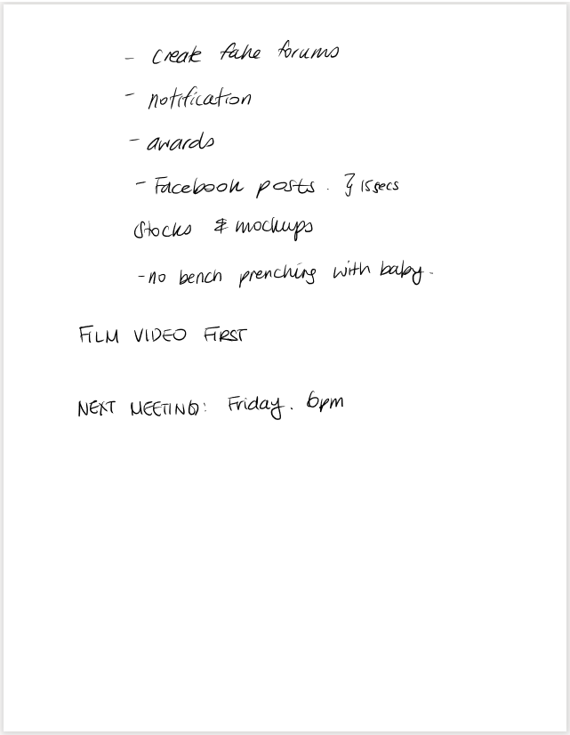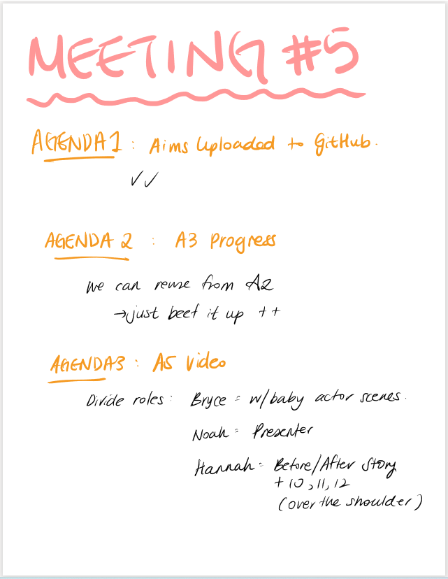**Meeting Minutes:**

**11 February 2022**

**6:00 PM**

**Video Recording Link:**

<https://rmiteduau-my.sharepoint.com/:v:/g/personal/s3932976_student_rmit_edu_au/Eez08hHTQxNIgb_s0Ic_aWYBG-2KlDmpkcPjptjZnKPo8A?e=DlBzkm>

**Meeting Agenda:**

Title of meeting: Finish up A3, video

Date and time of meeting: 11/02/2022 - 6:00PM

Chaired by:

Attendees: Daniel C, Bryce M, Hanna S, Rhiannon L, Noah E

**Meeting goal**: Finalise A3, and more talk about A5

**Agenda Item 1**: Finalising A3

Time: 15

Purpose: see what’s left, and discuss the finishing touches

Leader: TBA

1. See if we have met the deadline
2. Set a new deadline if needed
3. Discuss report layout and design
4. Anything else

**Agenda Item 2**: video discussion

Time: rest of meeting

Purpose: general talk

Leader: TBA

1. Have a look at what’s been done so far
2. General chat

**Meeting Minutes:**

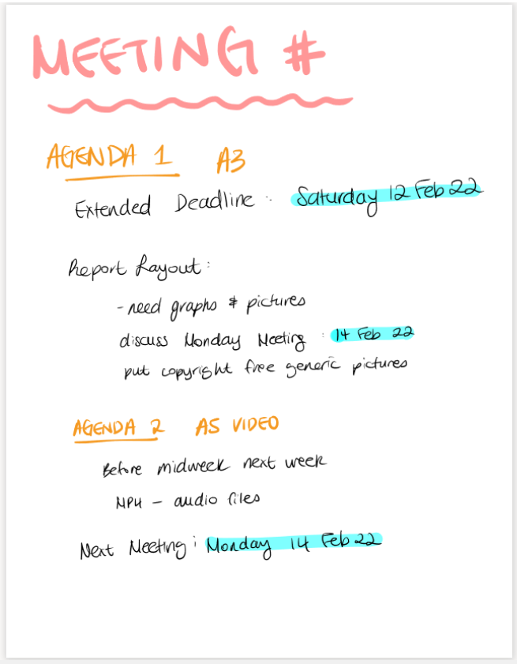

**14 January 2022**

**6:00 PM**

**Video Recording Link:**

<https://rmiteduau-my.sharepoint.com/:v:/g/personal/s3932976_student_rmit_edu_au/EUb9nEdZ2x9Ip5NEznNzvT4BZ-ihRTQcAxSEnMaega7Gdw>

**Meeting Agenda:**

Title of meeting: Last meeting for A3!!

Date and time of meeting: 14/02/2022 – 6:00PM

Chaired by:

Attendees: Daniel C, Bryce M, Hanna S, Rhiannon L, Noah E

**Meeting goal**:

**Agenda Item 1**: Look at the group reflection

Time: 5

Purpose: make sure everyone is happy with it

Leader:

1. Review group reflection
2. Discuss any changes to be made

**Agenda Item 2**: Check last remaining A3 segment progress

Time: 5

Purpose: See how close the last section is to being completed

Leader:

1. Make sure last section to be finished is completed or close

**Agenda Item 3**: look at the priorities on the scope and limits table

Time: 5

Purpose: agree on the priorities

Leader:

1. Review Scopes & Limits table for priorities
2. Discuss any changes to be made

**Agenda Item 4**: Set deadline for formatting to be completed and upload of final report

Time: 5

Purpose: set final date of assignment

Leader:

1. Set final deadline for all formatting and submission of final reports
2. Set final deadline for webpage to be completed

**Agenda Item 5**: SparkPLUS!!!

Time: 5

Purpose: reminder about SparkPLUS and what is required

Leader:

1. Remind everyone to complete SparkPLUS when it is open
2. Make sure everyone knows to complete the rating scales for each member of the group as well as the individual feedback comments for all group members, and to ensure it is submitted correctly

**Meeting Minutes:**

